**DA Report**

*A report submitted in partial fulfillment of the requirements for the Award of Degree of*

**BACHELOR OF TECHNOLOGY**

**IN**

**ARTIFICIAL INTELLIGENCE & DATA SCIENCE ENGINEERING**

by,

**ONKAR JAMMA**

**ROLL NO 21**



**DEPARTMENT OF ARTIFICIAL INTELLIGENCE & DATA SCIENCE ENGINEERING**

**Pradnya Niketan Education Society, Pune.**

**NAGESH KARAJAGI *ORCHID* COLLEGE OF ENGGINEERING & TECHNOLOGY, SOLAPUR.**

**2023-2024**

* View (Car_details)

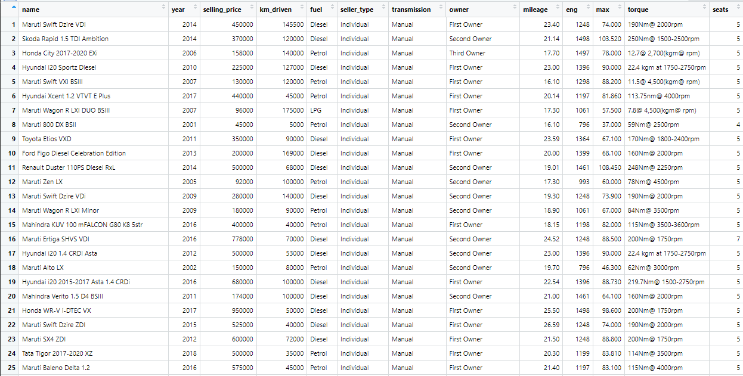

"

* Summary

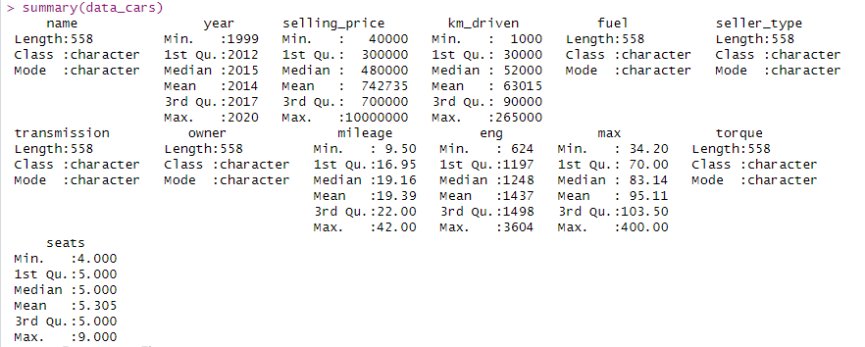

**Description :-**

Engine Size vs. Mileage: Smaller engines tend to offer better mileage, but factors like fuel type and driving conditions also influence it. Engine Size vs. Kilometers Driven: No direct correlation; larger engines can vary in usage based on car type and owner preferences. Mileage vs. Kilometers Driven: Older cars with higher kilometers may have reduced mileage due to wear, but this varies based on maintenance and driving habits.

**Engine Size vs. Mileage**: Smaller engines generally offer better mileage, but fuel type and driving conditions also matter.

**Engine Size vs. Kilometers Driven**: No direct link; engine size doesn't always dictate usage.

**Mileage vs. Kilometers Driven**: Older cars with more kilometers may have lower mileage due to wear; actual mileage depends on maintenance and driving habits.

* Variables

1. KiloMeter Driven

Summary Of Kilometer Driven Column

summary(data_cars$km_driven)

Min. 1st Qu. Median Mean 3rd Qu. Max.

1000 30000 52000 63015 90000 265000

Skewness Kurtosis

skewness(data_cars$km_driven) kurtosis(data_cars$km_driven)

[1] 1.158306 [1] 4.833402

* The lowest kilometer reading for a car in the dataset is 1,000 km.
* 25% of the cars have been driven 30,000 km or less.
* 50% of the cars have been driven 52,000 km or less.
* The average kilometer reading for cars in the dataset is approximately 63,015 km.
* 75% of the cars have been driven 90,000 km or less.
* The highest kilometer reading for a car in the dataset is 265,000 km.

hist(data_cars$km_driven)

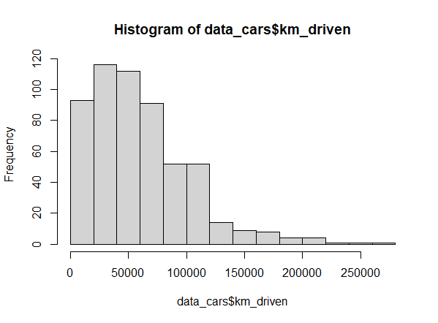

1. Selling Price

Summary Of Selling Price Column

summary(data_cars$selling_price)

Min. 1st Qu. Median Mean 3rd Qu. Max.

40000 300000 480000 742735 700000 10000000

Skewness Kurtosis

skewness(data_cars$selling_price) kurtosis(data_cars$selling_price)

[1] 4.117156 [1] 24.91825

* The lowest selling price for a car in the dataset is 40,000.
* 25% of the cars have a selling price of 300,000 or less.
* 50% of the cars have a selling price of 480,000 or less.
* The average selling price across all cars is approximately 742,735.
* 75% of the cars have a selling price of 700,000 or less.
* The highest selling price for a car in the dataset is 10,000,000.

hist(data_cars$selling_price)

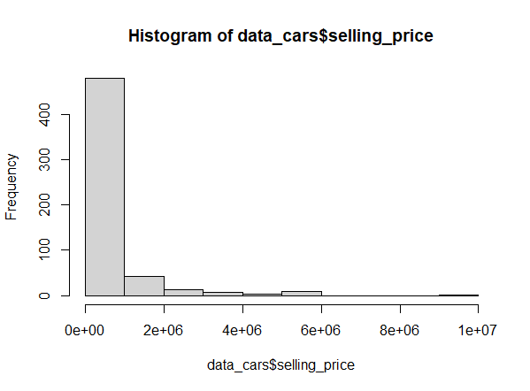

1. Engine

Summary Of Engine Column

summary(data_cars$eng)

Min. 1st Qu. Median Mean 3rd Qu. Max.

624 1197 1248 1437 1498 3604

Skewness Kurtosis

skewness(data_cars$eng) kurtosis(data_cars$eng)

[1] 1.344163 [1] 4.536894

* The smallest engine displacement in the dataset is 624 cc.
* 25% of the cars have an engine size of 1197 cc or less.
* 50% of the cars have an engine size of 1248 cc or less.
* The average engine size across all cars is approximately 1437 cc.
* 75% of the cars have an engine size of 1498 cc or less.
* The largest engine displacement in the dataset is 3604 cc.

hist(data_cars$eng)

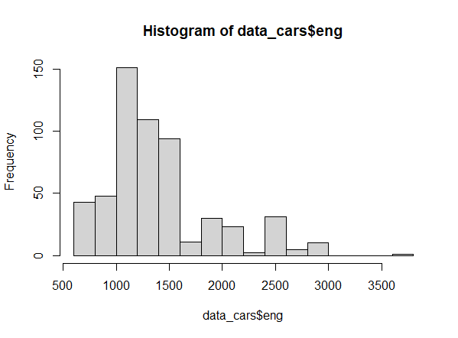

1. Seats

Summaary Of Car Seats Column

summary(data_cars$seats)

Min. 1st Qu. Median Mean 3rd Qu. Max.

4.000 5.000 5.000 5.305 5.000 9.000

Skewness Kurtosis

skewness(data_cars$seats) kurtosis(data_cars$seats)

[1] 1.995236 [1] 6.003567

* The smallest number of seats in the dataset is 4 seats.
* 25% of the cars have 5 seats or fewer.
* 50% of the cars have 5 seats.
* The average number of seats across all cars is approximately 5.305 seats.
* 75% of the cars have 5 seats or fewer.
* The largest number of seats in the dataset is 9 seats.

hist(data_cars$seats)

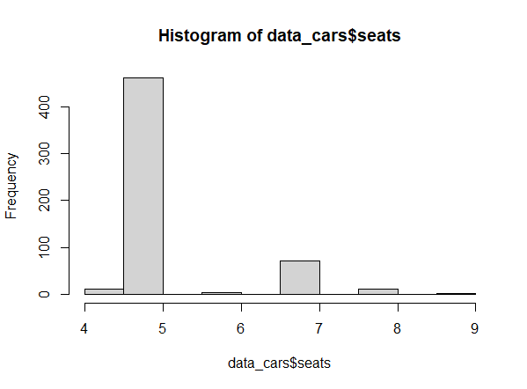

1. Mileage

Summary Of Mileage Column

summary(data_cars$mileage)

Min. 1st Qu. Median Mean 3rd Qu. Max.

9.50 16.95 19.16 19.39 22.00 42.00

Skewness Kurtosis

skewness(data_cars$mileage) kurtosis(data_cars$mileage)

[1] 0.4154223 [1] 4.319912

* The lowest mileage for a car in the dataset is 9.50 km/l.
* 25% of the cars have a mileage of 16.95 km/l or less.
* 50% of the cars have a mileage of 19.16 km/l or less.
* The average mileage for cars in the dataset is approximately 19.39 km/l.
* 75% of the cars have a mileage of 22.00 km/l or less.
* The highest mileage for a car in the dataset is 42.00 km/l.

hist(data_cars$mileage)

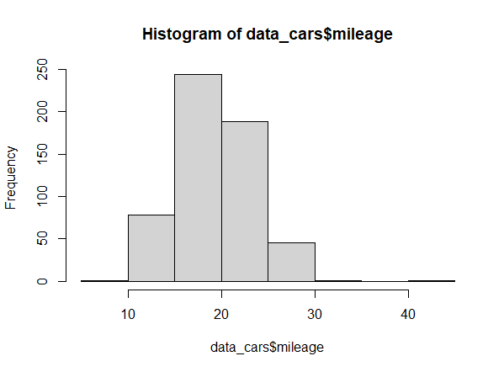

hist(data_cars$eng)

Descriptive statistics:-

|  |  |  |  |  |  |  |
| --- | --- | --- | --- | --- | --- | --- |
|  | **Mean** | **Median** | **Minimum** | **Maximum** | **SD** | **IQR** |
| **Selling**  **Price** | 742734.7 | 480000 | 40000 | 1e+07 | 999592.5 | 4e+05 |
| **Km**  **Driven** | 63015.35 | 52000 | 1000 | 265000 | 43781.41 | 60000 |
| **Mileage** | 19.39297 | 19.16 | 9.5 | 42 | 3.975563 | 5.05 |
| **Engine** | 1437.129 | 1248 | 624 | 3604 | 497.2197 | 301 |
| **Seats** | 5.304659 | 5 | 4 | 9 | 0.7951919 | 0 |

Minimun & Maximum of Different Varaibles of cars :-

|  |  |  |  |  |  |
| --- | --- | --- | --- | --- | --- |
|  | **Selling price** | **Km Driven** | **Mileage** | **Engine** | **Seats** |
| **Minimum** | Maruti Alto 800 CNG LXI Optional | Maruti Ertiga VDI | Maruti Swift Dzire VDi | Maruti Baleno Delta 1.2 | Hyundai Accent GLE |
| **Maximum** | Hyundai EON Magna Plus | Kia Seltos HTE D | Hyundai EON Magna Plus | Maruti Swift Dzire VDi | Tata Tiago 1.2 Revotron XZ |

* **Correlation Between Engine Size and Kilometers Driven**
* Engine Displacement (cc): Mean = 1437 cc
* Mileage: Mean = 19.39 km/l
* Kilometers Driven: Mean = 63,015 km

**Engine Displacement vs. Mileage**: On average, a car with an engine size of around 1437 cc achieves approximately 19.39 km/l.

**Engine Displacement vs. Kilometers Driven**: On average, a car with an engine size of around 1437 cc has been driven approximately 63,015 km.

**Maximum Mileage**: 42.00 km/l **Maximum Engine Displacement (cc)** : 3604 cc

So, for the maximum mileage of 42.00 km/l, a car would require an engine displacement of 3604 cc.

**Diesel:** Diesel engines generally offer better mileage compared to petrol engines due to their higher energy density and efficiency.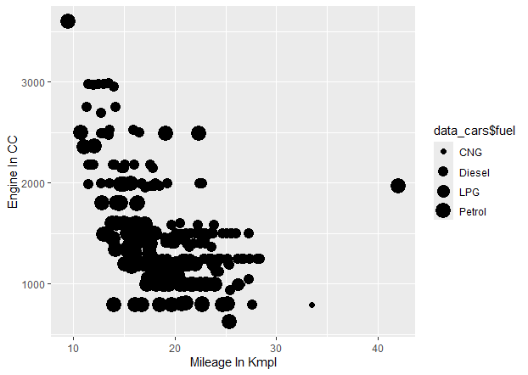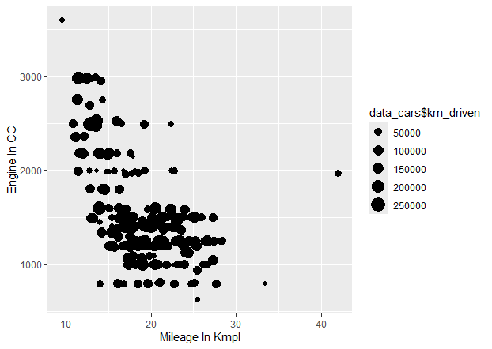

**Conclusion :-**

In conclusion, the analysis of the car data provided valuable insights into various aspects of the automotive industry. Through thorough examination and statistical techniques, several key observations have been made.

Firstly, regarding sales performance, it is evident that certain models or brands exhibit higher demand compared to others. Understanding the factors contributing to this discrepancy, such as pricing, features, or market trends, can aid in devising effective marketing strategies and product positioning.

Secondly, analyzing customer preferences revealed notable trends in terms of vehicle attributes prioritized by consumers. Whether it be fuel efficiency, safety features, or technological advancements, aligning product development with these preferences can enhance competitiveness and customer satisfaction.

Furthermore, exploring demographic patterns uncovered nuances in consumer behavior across different segments. Tailoring marketing campaigns and product offerings to specific demographics can foster stronger connections with target audiences and drive sales growth.

Moreover, examining regional variations shed light on geographical factors influencing car sales and preferences. Adapting distribution channels and product offerings to suit regional preferences can capitalize on market opportunities and mitigate risks associated with localized economic conditions.

In conclusion, leveraging the insights derived from this analysis can inform strategic decision-making processes within the automotive industry. By understanding consumer preferences, market dynamics, and regional variations, stakeholders can enhance competitiveness, optimize resource allocation, and ultimately drive sustainable growth in the ever-evolving automotive landscape.